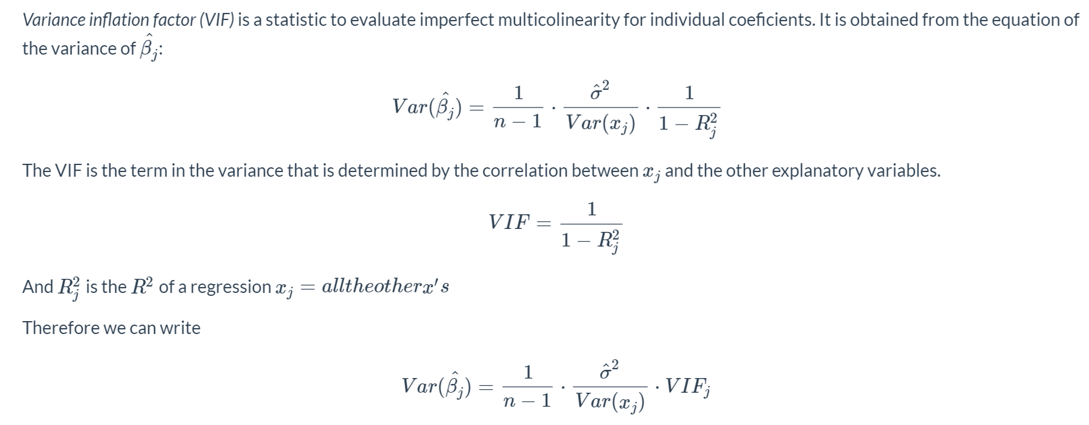

library(tidyverse)

library(wooldridge)

library(stargazer)

**library(car)**

lmres <- lm(log(wage) ~ educ + exper + tenure, data = wage1)

# Regression output:

stargazer(lmres, type = "text")

* calculate VIF :

**vif(lmres)**

* **R will drop perfectly co-linear variables in the regression; however, you cannot include perfectly co-linear variables when calculating VIF**
* **A histogram of the residuals**

resid <- data.frame(lmres$residuals)

ggplot(resid, aes(lmres.residuals)) +

geom_histogram(aes(y = ..density..), fill = "lightgreen") + geom_density(col = 4) +

stat_function(fun = dnorm, args = list(mean = 0, sd = rmse1), col = 2)

